Page 1
Troop 23
Adult Leader’s Position Responsibilities
Chartered by:
Mt. Lebanon United Methodist Church
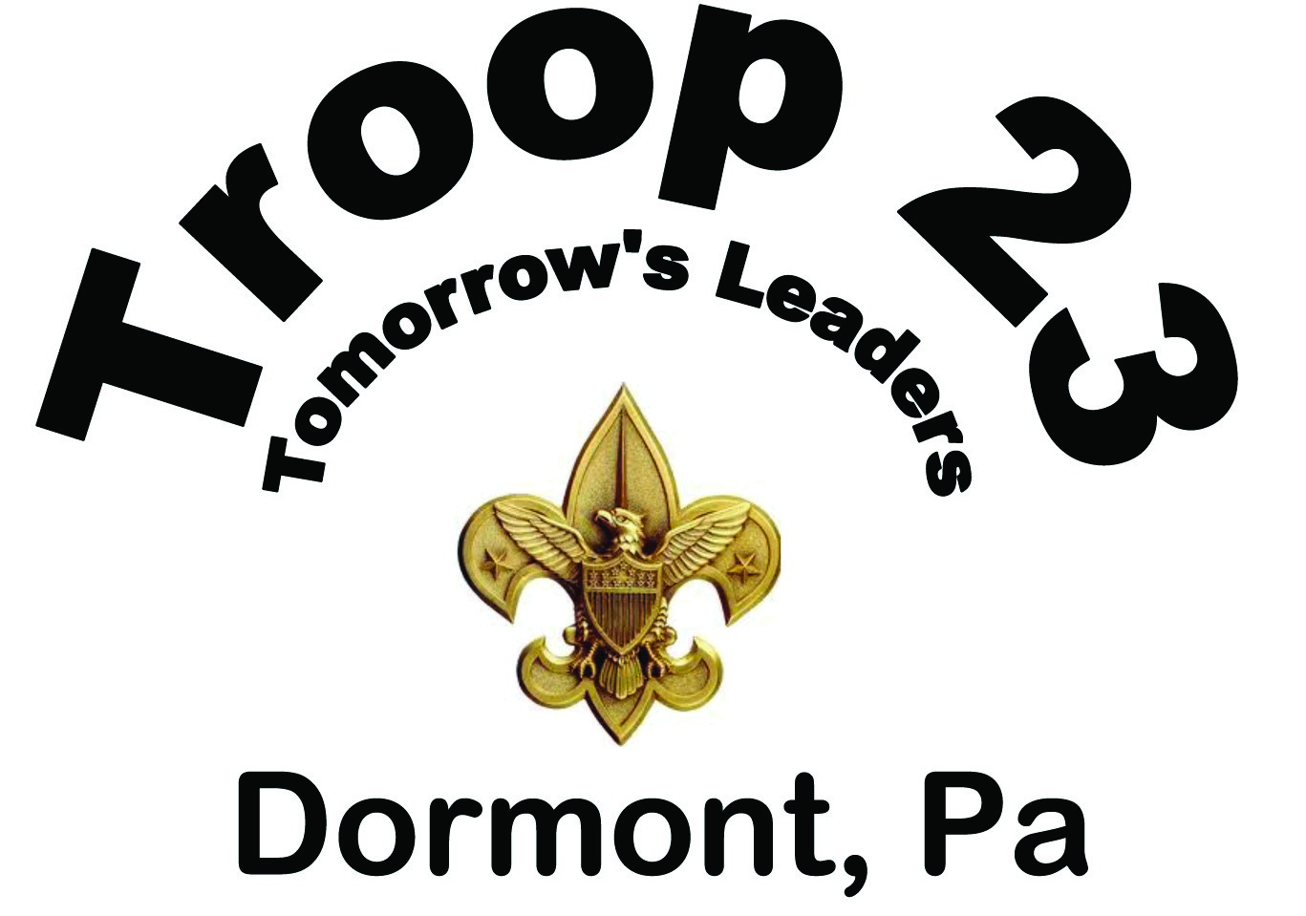

Table of Contents
Scoutmaster 4
Assistant Scoutmaster 5
Charter Organization Representative (COR) 6
Troop Committee 7
Committee Chair 8
Available positions for the Troop Committee 9
Unit Secretary/Webmaster 9
Unit Treasurer 9
Unit Advancement Chair/Coordinator 10
Webelos Transition Coordinator/Membership Chair 11
Unit Training Chair 12
Unit Activities Chair/Camping Coordinator 13
Unit Quartermaster/Equipment Coordinator 14
Troop Chaplain 15
Unit Fundraising Chair 16
Public Relations Chair/Webmaster 17
Scouting for Food Chair 17
Court of Honor Coordinator 17

Scoutmaster
The Scoutmaster is the adult responsible for working directly with the Scouts to help them create the program for the troop. The Scoutmaster trains boy leaders to run the troop by providing direction, coaching, and support.

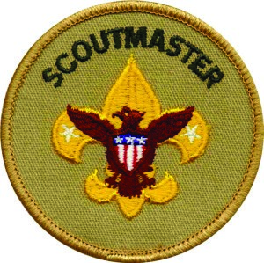
Responsibilities
- Trains and guides boy leaders.
- Works with other responsible adults to bring Scouting to boys. • Uses the methods of Scouting to achieve the aims of Scouting.
- Can be male or female, but must be at least 21 years of age.
- Is appointed by the head of the chartered organization.
- With the committee treasurer begins the preparation of the annual budget.
Qualification.
Adults citizens, or adult non-citizens who reside within the country, may register with the Boy Scouts of America in any capacity if they agree to abide by the Scout Oath or Promise and the Scout Law, to respect and obey the laws of the United States of America, and to subscribe to the precepts of the Declaration of Religious Principle.
Must be 21 years of age or older.

Minimum Training Requirements
- Youth Protection training; must be re-certified every two years.
- Introduction to Outdoor Leader Skills (Indoor & outdoor sessions)
- Merit Badge Counselor training
- Supplemental online training related to outdoors as follows:
- Safe Swim Defense
- Physical Wellness
- Safety Afloat
- Climb On Safely
- Trek Safely
- Weather Hazards
- Suggested but not required: Wood Badge – Advanced Leadership skills
The Scoutmaster, Assistant Scoutmaster and Troop Chaplain are considered Direct youth contact leaders by BSA.
“The more responsibility the Scoutmaster gives his patrol leaders, the more they will respond.”
“The most important object in Boy Scout training is to educate, not instruct.”
“I had stipulated that the position of Scoutmaster was to be neither that of a schoolmaster nor of a commander Officer, but rather that of an elder brother among his boys, not detached or above them individually, able to inspire their efforts and to suggest new diversions when his finger on their pulse told him the attraction of any present craze was wearing off.” Lessons from the Varsity of Life, 1933
— Robert Baden-Powell

Assistant Scoutmaster

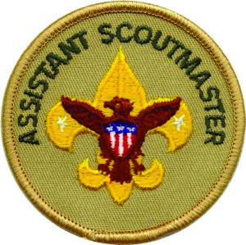
Responsibilities
- Assist the Scoutmaster as directed
- Works with other responsible adults to bring Scouting to boys.
- Uses the methods of Scouting to achieve the aims of Scouting.
Assistant Scoutmaster assists in providing two-deep leadership in smaller troops; may be assigned to one or more regular patrols in larger troops.
- New-Scout patrol. Works with the Troop Guide, new-Scout Patrol Leader and Den Chief to help deliver the troop program to Scouts without experience (often 11- and 12-year olds) entering the troop. While not the proper title, this position is more commonly known as the “11-year-old Scout Leader”
- Venture. Works with the Venture Patrol Leader in delivering high adventure and sports program the Venture patrol who’s members are usually 13+ and of higher rank.

Assistant Scoutmasters may be directed by the Scoutmaster to assist in skills instruction and adult assistance with delivering the troop program. Duties may overlap or assist with roles in the Troop Committee. Assistant Scoutmasters not on BSA’s troop organizational chart may be assigned and charged for specific duties. Common examples are:
- Program. Understands the troop program and may be assigned to work with an Assistant Senior Patrol Leader in charge of program.
- Service. Assists in the troop’s service activities, and may be assigned to work with the Quartermaster.
- Technology. Understands the troop computer and audio-visual equipment.
- Administration. Assists with records and materials; may be assigned to work with the Assistant Senior Patrol Leader.
- 11-year-olds. Functions as an “assistant” to the Assistant Scoutmaster Provides two-deep leadership in this patrol.
Qualification.
- This is the only troop adult leader position for adults age 18-20.
- Can be male or female, but must be at least 18 years of age.
- Is appointed by the Scoutmaster and approved by the Troop Committee Chair.
- Abide by the Scout Oath or Promise and the Scout Law.
- Subscribe to the precepts of the Declaration of Religious Principle

Minimum Training
- Complete Youth Protection training within 90 days of assuming a leadership position; must be re-certified every two years.
- Fast Start Online training
- Scoutmaster Indoor and Outdoor leader training
- Merit Badge Counselor training
- Complete Supplemental online training related to outdoors as follows:
- Safe Swim Defense Physical Wellness
- Safety Afloat Climb On Safely
- Trek Safely Weather Hazards
- Suggested but not required: Wood Badge – Advanced Leadership skills

Charter Organization Representative (COR)
Description
The Chartered Organization Representative (COR) is the direct contact between the unit and the Chartered Organization. This individual is also the organization’s contact with the District Committee and the Local Council. The chartered organization representative may become a member of the district committee and is a voting member of the council. If the chartered organization has more than one unit, one representative serves them all. The Chartered Organization Representative appoints the Unit Committee Chair.

Responsibilities
- Help select the right leadership for the unit.
- Encourage unit leaders and committee members to take training.
- Promote well-planned unit programs.
- Serve as a liaison between the units and the organization.
- Organize enough units.
- Promote the recruiting of new members.
- See that boys transition from unit to unit.
- Help with the charter renewal.
- Suggest Good Turns for the organization.
- Encourage the unit committee to hold meetings.
- Cultivate organization leaders.
- Encourage outdoor program activities.
- Emphasize advancement and recognition.
- Utilize district help and promote the use of district personnel and materials.
- Use approved unit finance policies.
- Encourage recognition of leaders.
- Cultivate resources to support the organization.
- Represent the organization at the council level.

Qualifications
Qualification. Adults citizens, or adult non-citizens who reside within the country, may register with the Boy Scouts of America in any capacity if they agree to abide by the Scout Oath or Promise and the Scout Law, to respect and obey the laws of the United States of America, and to subscribe to the precepts of the Declaration of Religious Principle. Must be 21 years of age or older.

Training
- Complete Youth Protection training; must be re-certified every two years.
- Fast Start Training—online training you can take right now.
- Leader Specific—Charter Organization Representative Training

Troop Committee
Description

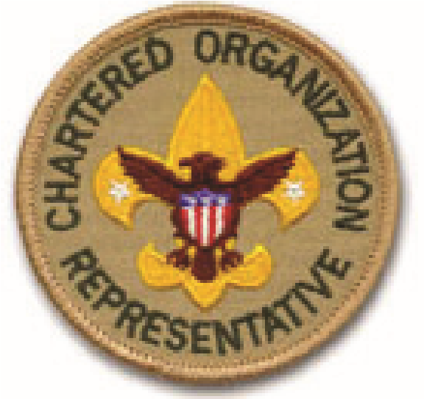
The Boy Scout Troop Committee is responsible for conducting the business of the troop, setting policy and helping the Scoutmaster and Scouts with the outdoor program and other planned activities. The committee also has the responsibility to provide adults for boards of review. The Boards of Review also serve as quality checks of the Scouting program as delivered by the Scoutmaster and the Assistant Scoutmasters. The committee consists of parent volunteers who fulfill various roles on the committee
The Scoutmaster and Assistant Scoutmasters are NOT formal members of the committee but are advisers to the committee. They may attend committee meetings to communicate scout plans and to coordinate the needs of the Scouts.

Minimum positions for a chartered troop
A chartered Boy Scout troop requires a Chartered Organization Representative, a Committee Chairman, at least two committee members, and a Scoutmaster.
Suggested Positions in the Troop Committee include:
Chartered Organization Representative (mandatory) | Troop Membership Chair (see Webelos Transition)
Troop Committee Chairman (mandatory) | Troop Training Chair
Troop Secretary | Troop Public Relations Chair
Troop Treasurer | Troop Friends of Scouting (FOS) Chair
Troop Advancement Chair/Webelos Transition Coordinator | Troop Scouting for Food Chair
Troop Equipment Coordinator/Quartermaster | Troop Fundraising Chair/Popcorn Kernel
Troop Outdoor/Activities Chair | ScoutParent Unit Coordinator
The following qualifications and minimum training refers to all members of the committee. Additional requirements and training will be indicated for specific positions.

Qualifications
- Adults citizens, or adult non-citizens who reside within the country, register with the Boy Scouts of America
- Agree to abide by the Scout Oath or Promise and the Scout Law,
- Respect and obey the laws of the United States of America
- Subscribe to the precepts of the Declaration of Religious Principle
- Must be 21 years of age or older

Minimum Training for Troop Committee Members
- Complete Youth Protection training; must be re-certified every two years.
- Fast Start Training—online training
- Troop Committee Challenge
- Suggested but not required: Wood Badge – Advanced Leadership skills
The Scoutmaster, Assistant Scoutmaster and Troop Chaplain are considered Direct youth contact leaders by BSA.

Committee Chair
The unit committee chair is appointed by the chartered organization and registered as an adult leader of the BSA. The unit committee chairman serves as the Chief Executive Officer of the Troop Committee; he or she appoints and supervises the unit committee and unit leaders.

Responsibilities
- Organize the committee to see that all functions are delegated, coordinated and completed.
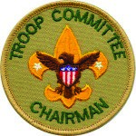
- Maintain a close relationship with the chartered organization representative and the Scoutmaster.
- See that unit leaders and committee members have training opportunities.
- Interpret national and local policies to the unit.
- Work closely with the Scoutmaster in preparing Troop Committee meeting agendas.
- Call, preside over, and promote attendance at monthly unit committee meetings and any special meetings that may be called.
- Ensure unit representation at monthly roundtables.
- Secure top-notch, trained individuals for camp membership.
- Arrange for charter review and recharter annually.
- Plan the charter presentation program.

Qualifications
- Adults citizens, or adult non-citizens who reside within the country, register with the Boy Scouts of America
- Agree to abide by the Scout Oath or Promise and the Scout Law,
- Respect and obey the laws of the United States of America
- Subscribe to the precepts of the Declaration of Religious Principle
- Must be 21 years of age or older

Minimum Training
- Complete Youth Protection training; must be re-certified every two years.
- Fast Start Training—online training
- Troop Committee Challenge
- Scoutmaster Indoor and Outdoor leader training
- Merit Badge Counseling Training
- Suggested but not required: Wood Badge – Advanced Leadership skills
Resources:
- Troop Resource Survey (http://www.scouting.org/filestore/pdf/34437.pdf)
- Journey to Excellence Spreadsheet/Scorecard

Available positions for the Troop Committee

Unit Secretary/Webmaster
The unit secretary is appointed by the unit committee chairman to keep minutes and records, send notices, and handle publicity. As Webmaster

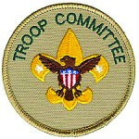
Responsibilities
- Keep minutes of meetings and send out committee meeting notices.
- Handle publicity through the website
- At each meeting, report the minutes of the previous meeting.
- Keep informed of all Boy Scouting literature, materials, records, and forms to help leaders function effectively. Help new Scout leaders by telling them what resources are available.
- Once yearly schedule is approved, create the Troop calendar and make it available for scouts, leaders and parents
- Working with the various leaders in the troop, develop materials for and maintain the Troop website (troop23dormont.scoutlander.com)

Unit Treasurer
The unit Treasurer is appointed by the committee chairman to handle unit funds, pay bills, maintain accounts, coordinate the annual Friends of Scouting (FOS) campaign, and supervise fundraising.

Qualifications
• Have a knowledge of accounting practices and be able to use computer programs that will enable reports to be generated on a regular basis and as needed.

Responsibilities
- Scoutmaster and committee treasurer begins the preparation of the annual budget.
- Maintain a bank account in the Troop’s name and arrange for all transactions to be signed by the designated people/positions.
- Supervise money-earning projects, including obtaining proper authorizations.
- Collect and record dues and other fees from Scouts and Scout Leaders and credit each person with payment.
- Keep up-to-date financial records.
- In collaboration with the Scoutmaster, lead in the preparation of the annual troop budget. • At the monthly Troop leaders’ meeting, report he troop’s financial condition
- Provide petty cash needed by leaders. Keep a record of expenditures.
- Guide the troop in conducting council-approved troop money-earning projects.
Resources:
- TRAINING THE UNIT TREASURER by Meredith Lamb Doctorate of Scouting (http://scouts.lamb-thielen.com/ data/Meredith’s-thesis-final-2-26-02.pdf)
- Unit Budget Planning & Worksheets (http://www.tidewaterbsa.com/forms/popplanner.pdf)

Unit Advancement Chair/Coordinator
The unit advancement chair is appointed by the committee chairman to ensure that the unit boards of review as needed and quarterly courts of honor. Ideally, the unit has goals of helping each Scout advance a rank each year and for new Scouts to reach First Class rank during their first year.
Responsibilities:
- Annually review the BSA Advancement Guidelines noting changes that effect current and new scouts.
- Have a working knowledge of the scouts’ advancement plans.
- Maintain accurate advancment information in Troop Master and present it to Scoutmaster for review.
- Arrange for Boards of Review of eligible scouts following completion of Scoutmaster Conferences.
- Using online advancement, register all advanements with council and ensure the correct information has been recorded by Council.
- Working with the COH Coordinator, Scoutmaster and Assistant Scoutmaster help plan and conduct induction and advancement recognition ceremonies.
- Working with the Webelos Transition Coordinator, help develop/maintain an ongoing working relationship between leaders of Packs and the troop that have webelos transition to Troop 23.
- Train parents, guardians and troop committee members in ways to stimulate Boy Scout advancement.
- Promote Boys’ Life magazine as an aid to advancement.
- Promote the wearing and proper use of uniform and insignia.
- Attend bi-monthly District Advancement meetings at Dormont United Methodist Church.
Resources:
- Boy Scout Handbook
- Current year’s Boy Scout Requirements
- www.scouting.org/scoutsource/BoyScouts in the Advancement and Awards section to find:.
- Current Guide to Advancement
- Merit badge pamphlets
- Getting the Most From Internet Advancement
- The Essentials of Merit Badge Counseling
- Guide to Advancement and Eagle Scout Service Project Workbook Overview - • Introduction to the Guide to Advancement (10 min.)
- Judgment Calls (24 min.)
- The Merit Badge Program
- Boards of Review
- Boards of Review Under Disputed Circumstances
- The Eagle Scout Service Project (17 min.)
- The Eagle Scout Application Process (8 min.)
- Eagle Scout Boards of Review (4 min.)
•
Training:
- Merit Badge Counselor
- Bi-monthly District Advancement meetings

Webelos Transition Coordinator/Membership Chair
The unit membership chair is appointed by the committee chairman to help ensure a smooth transition of new Scouts into the unit and orientation for new parents.

Responsibilities
- Arrange for periodic uniform inspections with the unit commissioner.
- Arrange for the annual membership inventory, a uniform inspection and the annual charter review meeting.
- Work with troop committee members to promote recruitment plans.
- Visit new families in their homes. Review with them the Scout requirements and “Parent Guide” in their son’s handbook. Emphasize the part that the family plays in their son’s advancement. Stress parent/ guardian participation at all troop functions and see that new families are introduced and feel welcome at troop meetings.
- Work with the Scout Master and Troop committee to develop and carry out a plan for year-round membership growth.
- Follow up on Boy Scout dropouts to help return them to full, active membership.Unit Activities Chair
The unit outdoor/activities chair is appointed by the committee chairman to secure tour permits and permission to use camping site, serve as transportation coordinator, ensure a monthly outdoor program.
Resources:
- Improved Webelos Transition (http://www.scouting.org/scoutsource/boyscouts/improvedwebelostransition. aspx)
- Patrol Plus (http://www.scouting.org/seabase/sitecore/content/home/boyscouts/resources/patrolplus. aspx)
- Troop open house (http://www.scouting.org/scoutsource/boyscouts/yearroundguide/open_house.aspx)

Unit Training Chair
The unit training chair is appointed by the committee chairman to ensure training opportunities are available, maintain training records and materials and is responsible for BSA Youth Protection training.
Responsibilities:
- Ensure troop leaders and committee members have opportunities for training.
- Encourages all leaders to attend ongoing training such as roundtable, outdoor training, youth protection and Wood Badge.
- Maintain an inventory of up-to-date training materials, videotapes, and other training resources.
- Work with the district training team in scheduling Fast Start training for all new leaders and adult family members.
- Be responsible for BSA Youth Protection training within the unit.
- Encourage periodic junior leader training within the troop/team at the council and national levels.
- Report to the unit committee at each meeting.
- Submit updated trained leader reports to the district and council.
Training:
- Edge Training
Resources:
- Guide to Leader Training (http://scouting.org/filestore/pdf/511-028_WEB.pdf)
- The Training Times (online BSA training updates)
- The Training Times (http://scouting.org/training/trainingupdates)

Unit Activities Chair/Camping Coordinator
Qualifications:
- Have access to a computer so that the necessary forms can be completed and submitted to council and shared with the parents.
- Completed supplemental training related to outdoor activities (see below)
Responsibilities:
- Help the Scout Master and Assistant Scout Masters plan and arrange for outdoor activities including relaying information regarding the types of supplemental training that are required for outings.
- Arrange for property, fire, and tour permits when required.
- Locate new camping, backpacking and High Adventure areas.
- Arrange for safe transportation when needed; develop and maintain a list of approved drivers for outings
- Plan first aid for emergencies including verifying that Troop First Aid Kit is “up-to-date” prior to any outing
- With the Quartermaster, help arrange for equipment, as needed.
- Arrange for Safe Swim Defense implementation for all outings involving swimming.
- Plan outings to help the troop qualify for Jouney To Excllence Award.
- Help inform parents and guardians about opportunities for family camping. Ensure that at least two adults have completed Introduction to Outdoor Leadership Skills (IOLS).
- Help promote Summer camp and resident camp opportunities.
- Be aware of BSA health and safety requirements and see that they are implemented.
- Know and carry out BSA outdoor program policy related to Boy Scouting.
- Review all activities to ensure that unit leaders comply with BSA policies in the Guide to Safe Scouting.
Training:
Complete Supplemental online training related to outdoors as follows:
- Safe Swim Defense
- Physical Wellness
- Safety Afloat
- Climb On Safely
- Trek Safely • Weather Hazards
Resources:
- BSA Guide To Safe Scouting
- Scoutmaster Handbook
- Policy on the Storage, Handling, and Use of Chemical Fuels and Equipment
- Age-Appropriate Guidelines for Scouting Activities
- Age Guidelines for Tool Use and Work at Elevations or Excavations
- The Sweet 16 of BSA Safety
- The Driver’s Pledge
- The Latest First Aid for Wounds and CPR
- Scouting Safety begins with leadership (The Sandwich Principle) (video)

Unit Quartermaster/Equipment Coordinator
The unit equipment coordinator, also known as the Adult Quartermaster is appointed by the committee chair to work with the youth Quartermaster. Together they are responsible for troop equipment inventory, storage and maintenance of equipment, advising the committee when new equipment is needed and making suggestions for replacing old or damed equipment.
Responsibilities:
- Complete an inventory of all troop equipment and supplies within 2 weeks of assuming position. Supply Troop Committee and Scoutmaster with this list.
- Work with Scout Quartermaster to:
- keep up to date inventory list of all troop equipment • keep equipment updated and complete.
- Ensure proper storage of all troop equipment.
- Supervise and help the troop procure, repair, and replace camping equipment.
- Ensure troop property is properly maintained, repaired and retired as needed.
- Supervise to assure that inventory list are kept current, and maintain copies of all forms needed by troop.
- Make periodic safety checks on all troop camping gear, and encourage the troop in the safe use of all outdoor equipment.
- Assure that license is current on trailer and that it is in safe running condition.
- Work closely with Scoutmaster, SPL, and Scout Quartermaster to ensure proper equipment is available for each outing.
- During the budget review, report to the Troop treasurer troop equipment that needs replaced or added with estimated costs.
- Report to the Troop Committee as necessary.
Resources:
- Sample Troop Gear List (http://www.troop137.com/html/Troop%20Equipment%20List.htm) • Guide to Safe Scouting (updated each year)

Troop Chaplain
The unit chaplain is appointed by the committee chairman to provide spiritual tone, guide the chaplain aide, give spiritual counseling and promote the regular religious participation of each member.

Responsibilities
- Provide a spiritual tone for troop/team meetings and activities.
- Give guidance to the chaplain aide.
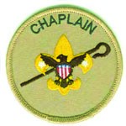
- Promote regular participation of each member in the activities of the religious organization of his choice.
- Visit homes of the Scouts in time of sickness or need.
- Give spiritual counseling service when needed or requested.
- Encourage Scouts to earn their appropriate religious emblems.
- Report to the troop/team committee each month.

Qualifications
- Adults citizens, or adult non-citizens who reside within the country
- Agree to abide by the Scout Oath or Promise and the Scout Law
- Respect and obey the laws of the United States of America
- Subscribe to the precepts of the Declaration of Religious Principle
- Must be 21 years of age or older

Minimum Training
- Youth Protection training within 90 days of assuming a leadership position; must be re-certified every two years.
- Troop Committee Challenge
- Suggested but not required: Wood Badge – Advanced Leadership skills

Resources
Manual for Chaplain Aides and Chaplains
The Scoutmaster, Assistant Scoutmaster and Troop Chaplain are considered Direct youth contact leaders by BSA.

Unit Fundraising Chair
The Unit Fundraising Chair/Popcorn Kernel works closely with the Committee Chair, Treasurer and Scoutmaster to determine the amount of funds needed by the unit and identifies possible fundraising projects. The Fundraising Chair/Popcorn Kernel” is appointed by the committee chairman to supervise Fundraising and ensure that every youth member has the opportunity to participate in Popcorn sales or other council Fundraising events. Currently the Troop does the following fundraisers: Popcorn, Spaghetti Dinner in January, Monthly Market Day through Keystone Oaks Swim team.
The Unit Fundraising Chair:
- Works with the Treasurer to ensure that youth participating in fundraising events have their individual scout account correctly credited
- Popcorn Sale:
- Arrange for the Popcorn orders to be delivered to Flag Plaza ontime, that the popcorn is picked up at the designated location by the unit and that product is picked up by members at a pre-defined location and time. Working with the Treasurer, verify that payment is complete and that Scouts receiving awards receivee them.
- Annual Spaghetti Dinner:
- Usuing last year’s information, contact vendors for donations.
- Have flyers prepared announcing the dinner to the community and distribute in the community

Training
- Popcorn Sales Organizer:
- Attend Popcorn Sales Training at flag plaza once a year.

Public Relations Chair/Webmaster
The unit public relations chair is appointed by the committee chairman to inform parents of their responsibilities in Scouting and with the chartered organization. Provides news and announcements about the unit to newspapers, bulletins of sponsors, web sites, etc. Promotes and stimulates service projects, Scouting Anniversary Week, Scout Sunday or Scout Sabbath, and family participation in unit events. Promotes new membership and lets people in the neighborhood know that Scouting is available.
Responsibilities:
- Know and follow the BSA Unit Website Guidelines
- Know and abide by the BSA Social Media Guidelines
- Obtain permission to use information/images on the website utilizing the Talent Release Form

Scouting for Food Chair
The unit Scouting for Food chair is appointed by the committee chairman to coordinate an annual food drive for the unit and reports the result to the district. The SFF chair works closely with the Pack to organize the announcement of the drive throughout Dormont and for food collection and distribution to the Brookline Food Bank. The Scouting for Food Chair is responsible for reporting the # of volunteers and hours worked as well as the amount of food collected.

Court of Honor Coordinator
This position is a non-registered leader (parent) position. This position works closely with the Advancement Chair and Committee Chair.
Responsibilities:
- Four times a year (March, June, September and December organize the food and decorations for the Troop’s Courts of Honor
- Contact families of troop members to arrange food and table decorations
- Supervise the set-up of the room for the COH
- Relay any supply needs to the Committee Chair & Treasurer
- Assist with the planning of any Eagle Courts of Honor if requested by the family of the Eagle candidate.
- Maintain Eagle Courts of Honor reference and history materials.
Resources:
- Scouting Ceremonies (www.scouting.org/filestore/pdf/Ceremonies.pdf)
Troop 23 is part of the Boy Scouts of America. We belong to the Laurel Highlands Council and are within the Conestoga District.
Boy Scouts are boys in 6th through 12th grades who are under the age of 18 years. The Dormont United Methodist Church became the Charter Organization for Troop 23 in 1926. The Troop moved in 2014 to Mt. Lebanon United Methodist Church after Dormont United Methodist Church closed.
Website: http:// http://www.mlumc.org/
3319 West Liberty Avenue, Pittsburgh, PA. 15216
Phone: (412) 531-7131
Email: info@mlumc.org

