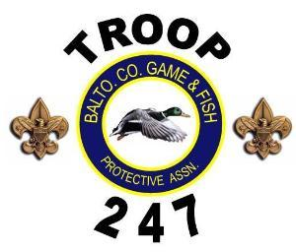

This awesome Scout binder belongs to

_______________________________

