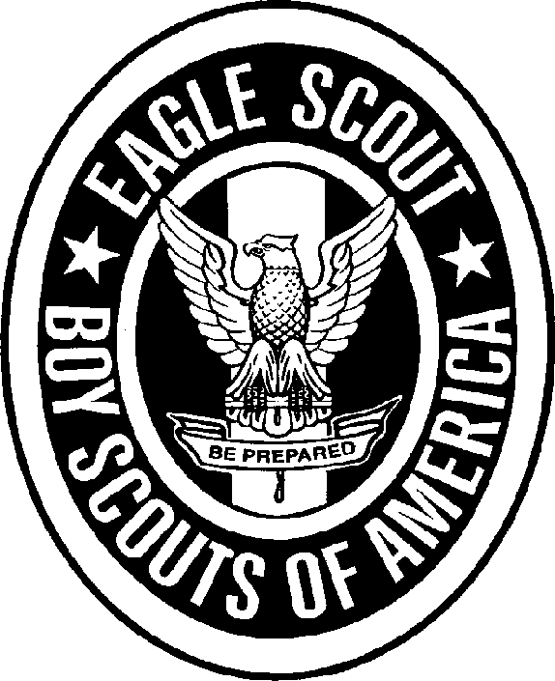

Eagle Personal Growth Agreement Conference
Name: _____________________________________Date____________ Age: ________ School Grade: ________
I have been a member of the Scouts for ____ months, including _____ months as a Life Scout.
I passed the Progress Revue Board on _____ / ____ / _______.

SCOUT SPIRIT:
As a Life Scout I have tried to continue the traditions of Scouting in my life by _______________________________
____________________________________________________________________________________________

ADVANCEMENT:
For my Eagle Scout Progress Award, I have earned the _______________________, ________________________, ______________________, ______________________, _______________________, ______________________, ______________________, ______________________, _______________________, and ___________________
Merit Badges.
The most interesting Merit Badge was __________________ because _____________________________________
_____________________________________________________________________________________________
Of the 11 Merit Badges I have earned, I learned most from ________________________ because _____________________________________________________________________________________________
The best Merit Badge Counselor I have met so far was ___________________________ because _____________________________________________________________________________________________

SERVICE:
For my Eagle Scout Service Project I ________________________________________________________________
_____________________________________________________________________________________________
_____________________________________________________________________________________________
_____________________________________________________________________________________________
_____________________________________________________________________________________________

LEADERSHIP:
As a Life Scout I have served as ___________________. I now understand that true Boy Scouting means BOY LEADERSHIP. I have tried to provide such leadership by _____________________________________________________________________________________________
_____________________________________________________________________________________________

PATROL:
I am ( ) proud of, ( ) disinterested in my Patrol because __________________________________________________
I think it needs __________________________________________________________________________________

TROOP:
I feel that Scouting has taught me ___________________________________________________________________
I believe the Troop ( ) has, ( ) has not provided me with a good Scouting experience.

Eagle Personal Growth Agreement Conference Continued
Name__________________________________________
SCOUT SPIRIT:
Now, that I have achieved the most coveted of all youth awards, I propose to show my pride in the Scout program and myself by _____________________________________________________________________________________

ATTENDANCE:
Troop Meetings ________ out of _________
Campouts _______out of ____________
PLC Meetings ___________out of____________
(Info from Troop Scribe)

ADVANCEMENT:
To continue my quest for the Eagle palm award, I propose to earn the
________________________, ___________________________, ___________________________,
________________________, and ________________________ Merit Badges

SERVICE:
I plan to continue serving others by: ________________________________________________________________

LEADERSHIP:
I realize that now that I am an Eagle, every Scout will be observing the way that I act as well as what I say. To be able to use this attention to the ends of accomplishing things is the true test of Leadership. I propose exert my Leadership by: _____________________________________________________________________________________________

PATROL:
My Patrol, the ___________ Patrol has been my most direct link to the Scouting program I will try to continue to serve and improve it by ____________________________________________________________________________________

TROOP:
I intend to continue to honor the Troop and program that has brought me to this place in my life by: _______________________________________________________________________________________________
** Please attach your life ambitions sheet that you filled out for your Eagle application.

I INTEND TO COMPLETE THE REQUIREMENTS FOR THE EAGLE PALM BY EARNING FIVE ADDITIONAL MERIT BADGES AND CONTINUING TO SERVE MY PATROL BY: _____ / ____ / ________.

Respectfully submitted: _____________________________

( ) Accepted
( ) Not accepted ______________________________ Scoutmaster. Dated ____ / ___ / ______
Recommendations:

Eagle Rank Requirements for

Scout_____________________ Date __________

Date/Initials | # | Requirements
 | 1 | Be active in your troop, team, crew, or ship for a period of at least six months after you have achieved the rank of Life Scout.
 | 2 | Demonstrate that you live by the principles of the Scout Oath and Law in your daily life. List the names of individuals who know you personally and would be willing to provide a recommendation on your behalf, including parents/guardians, religious, educational, and employer references.
 | 3 | Earn a total of 21 merit badges (10 more than you already have), including the following:  - First Aid  - Citizenship in the Community  - Citizenship in the Nation  - Citizenship in the World  - Communications  - Personal Fitness  - Emergency Preparedness OR Lifesaving  - Environmental Science  - Personal Management  - Swimming OR Hiking OR Cycling  - Camping  - Family Life  You must choose only one merit badge listed in items g and j. If you have earned more than one of the badges listed in items g and j, choose one and list the remaining badges to make your total of 21.
 | 4 | While a Life Scout, serve actively for a period of six months in one or more of the following positions of responsibility:  Boy Scout troop. Patrol leader, assistant senior patrol leader, senior patrol leader, troop guide, Order of the Arrow troop representative, den chief, scribe, librarian, historian, quartermaster, junior assistant Scoutmaster, chaplain aide, instructor, Webmaster, or Leave No Trace Trainer.  Venturing crew/ship. President, vice president, secretary, treasurer, boatswain, boatswain's mate, yeoman, purser, storekeeper, Webmaster, or Leave No Trace Trainer.

Eagle Rank Requirements continued for

Scout_____________________ Date __________

Date/Initials | # | Requirements
 | 5 | While a Life Scout, plan, develop, and give leadership to others in a service project helpful to any religious institution, any school, or your community. (The project should benefit an organization other than Boy Scouting.) A project proposal must be approved by the organization benefiting from the effort, your unit leader and unit committee, and the council or district before you start. You must use the Eagle Scout Service Project Workbook, BSA publication No. 512-927, in meeting this requirement.
 | 6 | Take part in a Scoutmaster conference.
 | 7 | Successfully complete an Eagle Scout board of review.

Notes
AGE REQUIREMENT ELIGIBILITY. Merit badges, badges of rank, and Eagle Palms may be earned by a registered Boy Scout, Varsity Scout, or Venturer. He may earn these awards until his 18th birthday. Any Venturer who achieved the First Class rank as a Boy Scout in a troop or Varsity Scout in a team may continue working for the Star, Life, and Eagle Scout ranks and Eagle Palms while registered as a Venturer up to his 18th birthday. Scouts and Venturers who have completed all requirements prior to their 18th birthday may be reviewed within three months after that date with no explanation. Boards of review conducted between three and six months after the candidate's 18th birthday must be pre-approved by the local council. A statement by an adult explaining the reason for the delay must be attached to the Eagle Scout Rank Application when it is submitted to the Eagle Scout Service. The national Advancement Team must be contacted for procedures to follow if a board of review is to be conducted more than six months after a candidate's 18th birthday.
If you have a permanent physical or mental disability, you may become an Eagle Scout by qualifying for as many required merit badges as you can and qualifying for alternative merit badges for the rest. If you seek to become an Eagle Scout under this procedure, you must submit a special application to your local council service center. Your application must be approved by your council advancement committee before you can work on alternative merit badges.
A Scout or Venturer with a disability may work toward rank advancement after he is 18 years of age if he meets the guidelines outlined in the Guide to Advancement.

